ASSIGNMENT 4

|  |  |
| --- | --- |
| PROJECT TITLE | SKILL JOB RECOMENDER |
| STUDENT NAME | SANTHOSH KUMAR M |
| STUDENT ROLLNO | 95071912082 |

1. **Pull an Image from docker hub and run it in docker playground.**

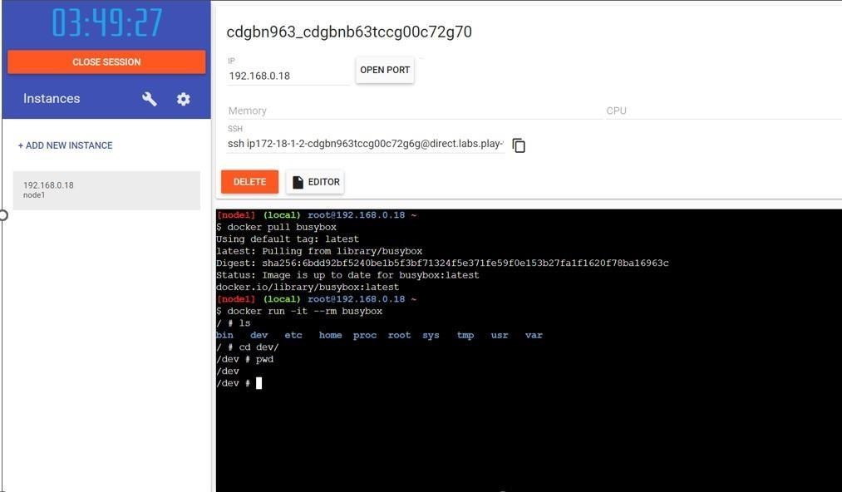

1. 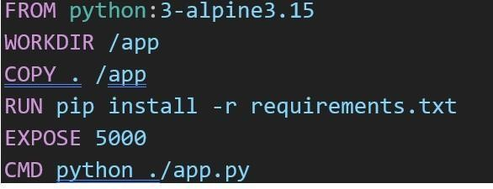**Create a docker file for the job portal application and deploy it in Docker desktop application.**

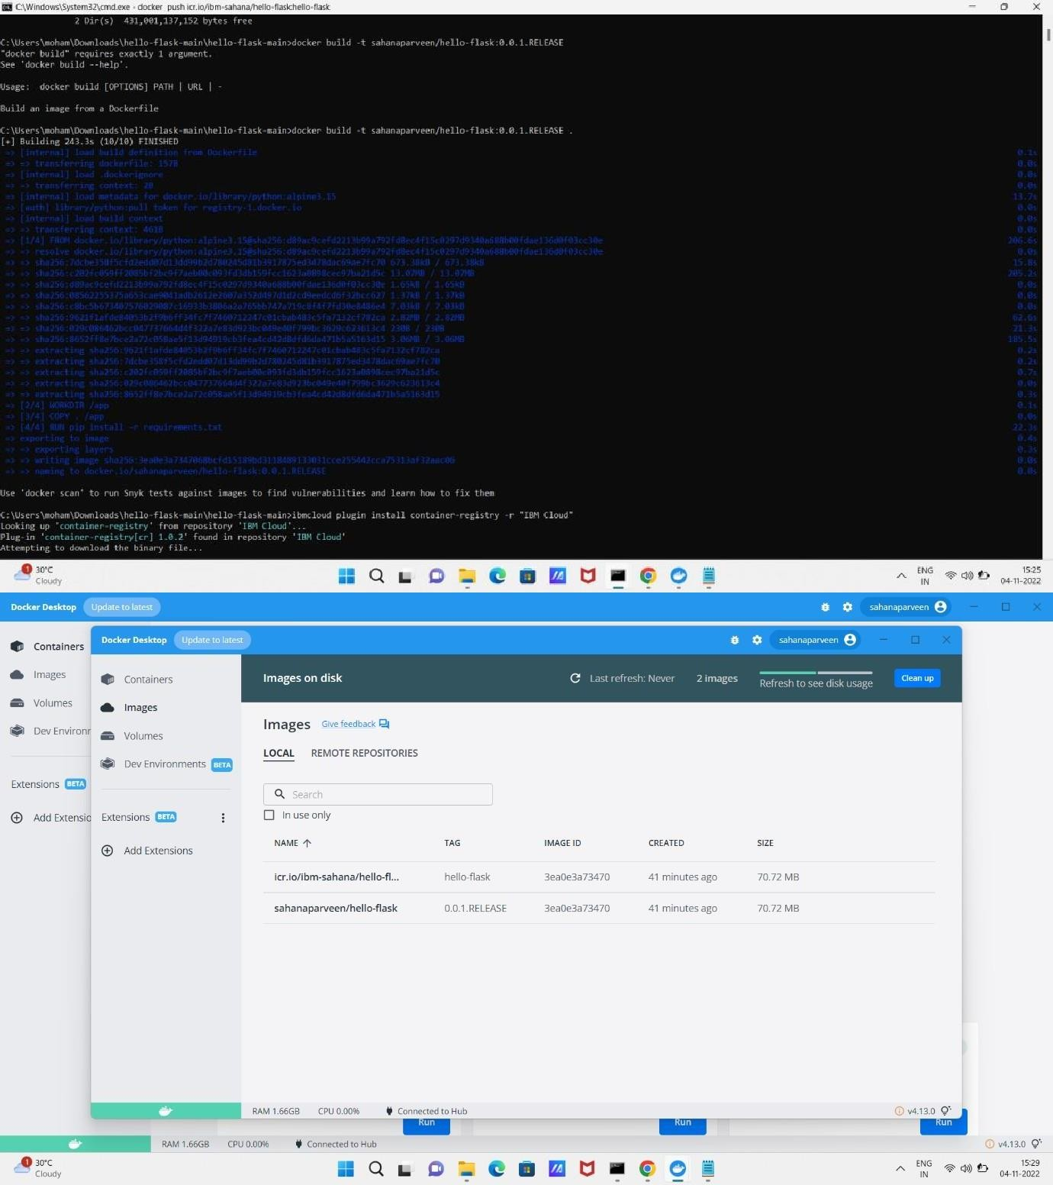

1. **Create a IBM container registry and deploy hello world app or job portal app.**

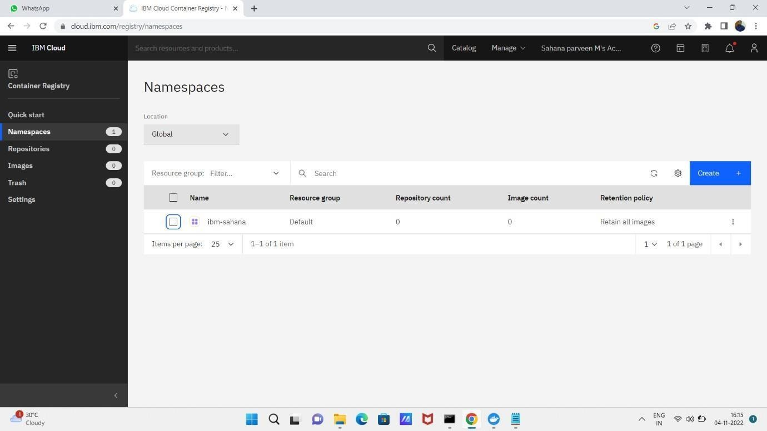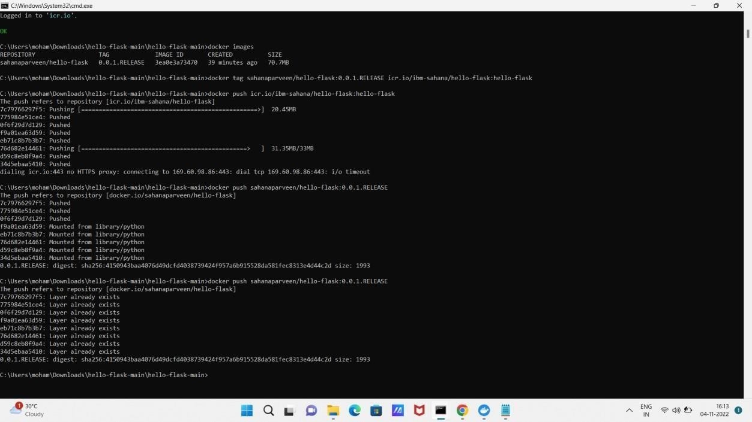

1. **Create a Kubernetes cluster in IBM cloud and deploy hello world image or job portal image and also expose the same app to run in node port.**

